**4 Guys and a Coffee**

Noah E Hall

Siddhartha Sankasala

Rushab Indi

Aman Arora

Information Technology Project Management

San Francisco State University

Spring 2015

Contents

Project Charter 4

1 - Team Name 4

2 - Project Overview 4

2.1 - Project Life Cycle 4

2.2 - System Development Life Cycle 4

3 - Scope 4

3.1 - Included 4

3.2 - Not Included 5

3.2.2 - User Experience 5

4 - Why We Chose this project 5

5 - Budget 5

6 - Team Members 6

7 - Agreed Upon Meeting Times 6

8 - A List of Team Rules and Expectations 6

9 - A Code of Ethics 6

10 - Signatures 6

Business Case 7

11 - Project Name 7

12 - Project Team 7

13 - Project Description 7

14 - MOV - Desired area of impact 7

14.1 - Strategic: 7

14.2 - Customer: 7

15 - MOV 7

15.1 - Desired Value of the IT Project 7

15.2 - Time Frame 7

16 - Make a Recommendation 8

Resources 8

17 - Human Resources: 8

17.1 - Project Sponsor 8

17.2 - Project Manager 8

17.3 - Business Superuser - SME 8

17.4 - Project Team Members 8

17.5 - Independent Contractors / Outsourced 9

18 - Technology 10

18.1 - Github.com 10

18.2 - Database 10

18.3 - Web Hosting 10

18.4 - Computers 10

18.5 - Internet 10

18.6 - Meetings 10

18.7 - Telephone lines 11

19 - Facilities 11

20 - Others 11

21 - Cost of Resources 11

21.1 - Human Resource 11

21.2 - Hardware/Software 12

21.3 - Network / Telecommunication 12

22 - General Overview 13

23 - Scope Change Request Flowsheet: 13

24 - Deliverable Structure Chart: 13

25 - Use Case Diagram: 15

26 - Context Level Diagram: 15

27 - Scope Change Process 16

27.1 - Scope Change Request Form 16

Project Schedule 28

Project Budget 34

Risk Management Plan 34

Quality Management Plan 34

Lesson Learned Reports 34

APPENDIX 34

MOV 34

Comparison of Alternatives 35

TCO 35

TBO 36

Weighted Scoring Model 37

NPV / ROI 38

# Project Charter

## 1 - Team Name

4 Guys and a Coffee

## 2 - Project Overview

4 *Guys and a Coffee* will develop a Social Networking B2B Commerce site connecting Creatives, Business Professionals, and Technologists that utilize Media technology in creating communication.

### 2.1 - Project Life Cycle

We will be managing the Project Life Cycle.

1. To deliver the core functionality and MVP.

2. MVP: Minimal Viable Product that entails the core

value-proposition of the B2B platform.

### 2.2 - System Development Life Cycle

We will be managing the System Development Life Cycle for each user story.

1. Analysis
2. Design
3. Implement
4. Test
5. Evaluate/Evolution

## 3 - Scope

### 3.1 - Included

Following are the functionalities that we have identified and will be implementing in our project.

#### 3.1.1 - User Stories

1. Create Profile
2. Create Project(s)
3. link to existing media assets to media records created on the site (e.g. Youtube, Vimeo, SoundCloud, etc.)
4. Post ads seeking collaboration for project or media
5. Apply to ads that have been posted by other users
6. Receive notifications on post
7. Message users
8. Liking media/projects
9. Searching for media, projects, or posts
10. Tagging media/projects

#### 3.1.2 - User Experience

### 3.2 - Not Included

Following are the functionalities that we have identified but currently out of scope.

1. User Stories
2. Friends
3. Upload media
4. In-depth filtering of posts
5. Filtering top hits
6. Filtering top projects
7. OAuth (standard for authorization)

### 3.2.2 - User Experience

1. Flat clickstream
2. Design

## 4 - Why We Chose this project

Technology has not been an equitable solution for all Industries or Communities. While empowering some, it has disadvantaged others. As Technologists and IT professionals, we have an innovative solution to a major problem in the creative industries: How can people use technology to collaborate and create new revenue streams and business models while allowing consumers free and open access to the media they love.

Fun reading: [http://adexchanger.com/data-driven-thinking/why-media-companies-are-being-eaten-by- tech-companies/](http://adexchanger.com/data-driven-thinking/why-media-companies-are-being-eaten-by-tech-companies/)

## 5 - Budget

1. Hosting
2. Server
3. Coffee
4. Studio Time

## 6 - Team Members

|  |  |  |
| --- | --- | --- |
| Noah E Hall | (602)376-8864 | noahedwardhall@gmail.com |
| Siddhartha Sankasala | (415)316-3347 | ssiddhartha.1193@gmail.com |
| Rushab Indi | (415)928-9681 | rushab.indi@gmail.com |
| Aman Arora | (415)590-1211 | aman3105@gmail.com |

## 7 - Agreed Upon Meeting Times

* Tuesday: 5-7pm
* Google Hangouts Video Call On weekends

## 8 - A List of Team Rules and Expectations

* **Resolve conflicts:** Come to a vote.
* **Misses a meeting:** Has to buy everyone coffee!
* **Does not contribute:** Escalation/you're fired!

## 9 - A Code of Ethics

We are committed to working together with a strong focus on doing the right thing. We aim to set high standards for ourselves personally and professionally. Our decisions will be driven by making the right choice when we are faced with an ethical dilemma. How do we arrive at this right choice? We analyze whether the decision we make is fair to all the parties involved and does not disadvantage others. We pledge to evaluate all the alternative choices and make a decision together as a team. In short, we aim to

1. Be Cool!

2. Be Understanding

3. Be Polite

4. Be Awesome

5. Drink coffee

## 10 - Signatures

 (*Noah E Hall*)  (*Siddhartha Sankasala*)

 (*Rushab Indi*)  (*AmanArora*)

# Business Case

## 11 - Project Name

* Fame.City BETA release

## 12 - Project Team

* 4 Guys and a Coffee
  + Noah Hall
  + Siddhartha Sankasala
  + Aman Arora
  + Rushab Indi

## 13 - Project Description

* Fame.City is an E2E Marketplace for Creatives, Business Professionals, and Technologists to collaborate and monetize their activities.

## 14 - MOV - Desired area of impact

### 14.1 - Strategic:

* + Penetration of new markets
  + Increased market share

### 14.2 - Customer:

* + Access to better services & products
  + More efficient and effective transaction processes

## 15 - MOV

### 15.1 - Desired Value of the IT Project

* Penetration of 3 markets
* Grow market share to 3%
* Create projects, post ads, and find collaborators in less than 3 screens
* Reduce energy required to to build a professional entertainment network from searching 3 or more sites to one site

### 15.2 - Time Frame

* Penetration of 3 markets: Q1 2016
* Grow Market share to 3% Q3 2016
* Create Projects, Post Ads, Find collaborators Q3 2015
* Reduce Energy Q3 2015

## 16 - Make a Recommendation

We recommend to move forward with the Fame.City Beta release project. This is the only project whose total benefits exceed its total cost, and our NPV and ROI investment back it up!

# Resources

## 17 - Human Resources:

### 17.1 - Project Sponsor

The Project Sponsor is accountable for the success or failure of Fame.City and must ensure that the project focusses on delivering upon its business objectives. A Project Sponsor must be a senior level executive with a natural management authority. The sponsor shall secure finances, support and guide the project manager for successful signoff of the project’s delivery. Make it more relevant to Fame.

### 17.2 - Project Manager

The Project Manager shall run the project on behalf of the Project Sponsor. The Project Manager monitors the project on a daily basis and ensures that the project deliverables are quality and produced within the agreed time and cost.Make it more relevant to Fame

### 17.3 - Business Superuser - SME

The Subject Matter Expert / Senior Users are specialists in a particular field having significant experience/ having received the training. At Fame.City, we need a an SME for project IT infrastructure and existing connections.

### 17.4 - Project Team Members

Team Members are responsible for executing tasks and producing deliverables as identified in the business plan within the timelines defined by the Project Manager. They are the daily drivers of the project which take it to fruition. Some examples with the requirements have been listed below.

#### 17.4.1 - Front End engineer

The Front End Engineer must have a strong fundamental understanding of HTML, CSS, and JavaScript. At Fame.City, we will be using HTML5 based on Rails, Bootstrap and Angular/Ember JS.

#### 17.4.2 - Database/Backend Engineer

The Backend Engineer is to have a strong knowledge of Rails, Ruby and JavaScript to interact with the front end and maintain a database for the transactions at Fame.City. We are using MySQL / PostGreSQL.

#### 17.4.3 - Systems Architect

The systems architect will prepare, construct and maintain the web server, computer systems and network when in production.

#### 17.4.5 - Marketer

The marketing executive will be involved in developing marketing campaign for events and promoting services at Fame.City. It includes planning, advertising, public relations, event organisation, product development, distribution, sponsorship and research.

#### 17.4.6 - Intern

As students at San Francisco State University ourselves, we are in touch with great students who offer a great spark and this is a mutually beneficial to both parties as it provides the students a platform for gaining industry experience.

### 17.5 - Independent Contractors / Outsourced

The advantage of hiring freelance professionals and independent contractors even though their cost is higher on a hourly basis is that they use their own equipment and this enables Fame.City to save on initial costs on expensive equipment that may not be reguarly used. Hiring them also gives Fame.City a flexibility in staffing.

#### 17.5.1 - Videographer

The videographer at Fame.City will shoot footage and edit content. The videographer will perform the tasks related to production and post-production.

#### 17.5.2 - Graphic Designer

An artistic designer to develop graphics and layouts for company logos and website content and event drives conducted by Fame.City

## 18 - Technology

### 18.1 - Github.com

For efficient management of source code of the website among IT team members. Github offers the team to share their code and preventing code conflicts when team members work on the same feature.

### 18.2 - Database

At Fame.City, we are using open source MySQL database management system which is based on SQL. The database will contain all the details of the transactions and records at Fame.City, as well as user management and hosting of media.

### 18.3 - Web Hosting

Fame.City will be hosted through Amazon AWS.

### 18.4 - Computers

As a startup, Fame.City offers its developers and team members an opportunity to Bring Your Own Device to work. This enhances productivity by enabling the team to work on a platform most comfortable to them and helps Fame.City save on the initial cost of acquiring hardware.

### 18.5 - Internet

Fame.City is a web startup and internet is the core lifeline of the project. The team currently uses Comcast for its internet as well as using the internet network provided at San Francisco State University. This also enables the IT team to work from home.

### 18.6 - Meetings

Fame.City has its meetings in reserved rooms at San Francisco State University. However when timelines are a problem, we have used technology to resolve the issue. This has been done using Google Hangouts and Skype, which are proven players in the industry and provide a high uptime to ensure communication is not hindered at Fame.City.

### 18.7 - Telephone lines

As a startup, Fame.City does not have an official landline but we are connected through our mobile devices on service provided by AT&T, Sprint, T-Mobile and Verizon.

## 19 - Facilities

As students of San Francisco State University, we use the facilities provided for a discussion and meetings with stakeholders. We also use it weekly team meetings for updates.

## 20 - Others

Training - Online courses at Youtube, Coursera and Udacity.

## 21 - Cost of Resources

### 21.1 - Human Resource

|  |  |  |
| --- | --- | --- |
| **Resource** | **Cost** | **Source** |
| Project Manager | $50 per hour | www.glassdoor.com |
| System Architect | $40 per hour | www.monster.com |
| Superuser / Subject Matter Expert | $40 per hour | www.monster.com |
| Front end engineer | $35 per hour | www.glassdoor.com |
| Back end engineer | $35 per hour | www.glassdoor.com |
| Marketer | $25 per hour | www.glassdoor.com |
| Intern | $15 per hour | www.myinterfase.com |
| Contractor - Videographer | $20 per hour | www.monster.com |
| Contractor - Graphic Designer | $25 per hour | www.monster.com |

### 21.2 - Hardware/Software

|  |  |  |
| --- | --- | --- |
| **Resource** | **Cost** | **Source** |
| Amazon AWS | $0.03/GB dependent on bandwidth on S3 server | www.amazon.com |
| GitHub | $7/mo | www.github.com |
| Amazon Relational Database Service (RDS) | $0.03/GB | www.amazon.com |
| Amazon EC2 server | $0.02/hour | www.amazon.com |
| Ruby on Rails | Open-source | rubyonrails.org |
| MySQL/PostGres | Open-source | www.mysql.com |

### 21.3 - Network / Telecommunication

|  |  |  |
| --- | --- | --- |
| **Resource** | **Cost** | **Source** |
| Google Hangouts | $0 | www.google.com/hangouts |
| Skype | $0 | www.skype.com |

**Scope Management Plan**

## 22 - General Overview

The Scope Management Plan is setup at Fame.City to put into writing the requests the changes during the life of an implementation project including scope, functionality and deliverables that have an impact on the budget, schedule and staff allocation.

For every scope change request coming in, the project management will evaluate the change request and its justification. They will consider the other alternatives available to arrive at the decision.

The goal of the Scope Management Plan is to ensure a standard methodology is applied for all incoming changes to Fame.City, and helps implement in an efficient manner the handling of changes.

## 23 - Scope Change Request Flowsheet:

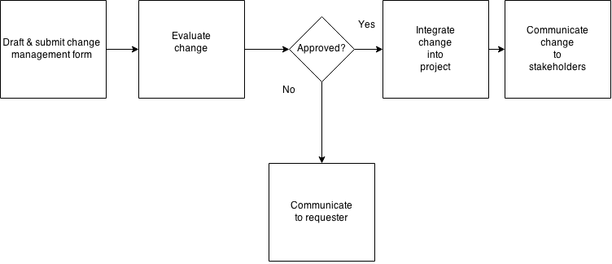

## 24 - Deliverable Structure Chart:

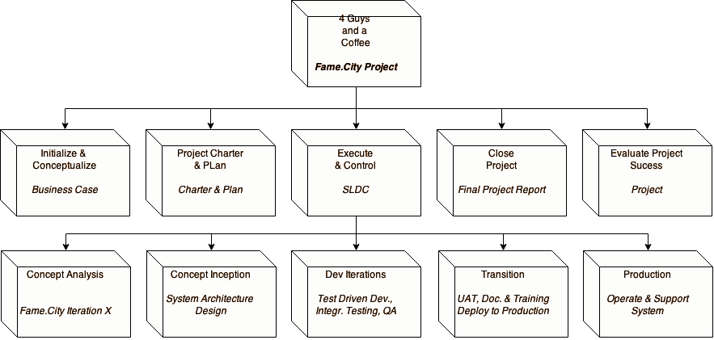

## 25 - Use Case Diagram:

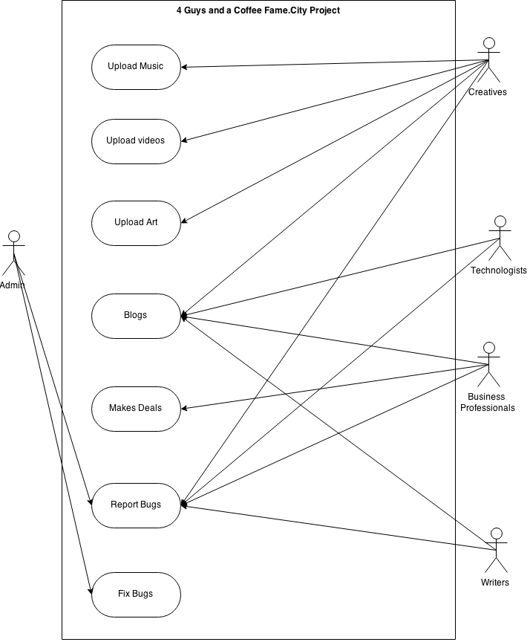

## 26 - Context Level Diagram:

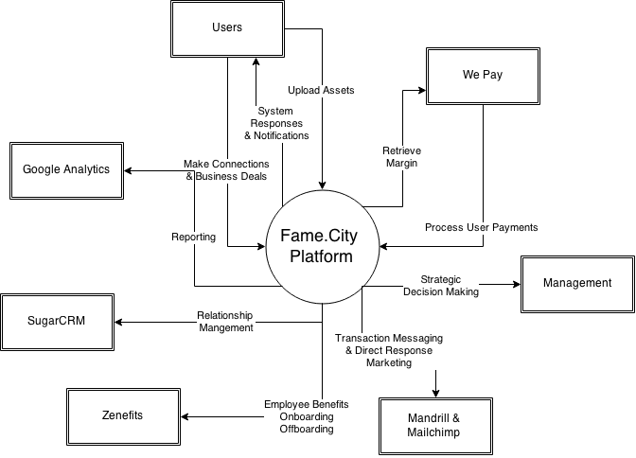

## 27 - Scope Change Process

The 4 Guys and a Coffee(4GC) understands that the users/clients may have a need to add or change the defined and agreed upon scope definition subsequent to the scope sign-off date. At the same time 4GC would require a definite scope to proceed with the execution of the project in an effective manner.

In order to manage this conflicting need, 4GC requires its clients and users to follow the Scope Control Plan. Every change from the agreed signed off scope has to be filled in a Scope Change Request form attached in appendix A. The project team will log these requests in a database and will need to be approved for the changes to be implemented by the Project Manager.

## 27.1 - Scope Change Request Form

4 Guys and a Coffee

Fame.City Project

SCOPE CHANGE REQUEST FORM

**VER – 1.001R – 04/07/2015**

**SCOPE CHANGE REQUEST FORM**

**Project Name:**_________________________ **Request Date:___________________**

**Client Name:__________________________ Requestor Name:________________**

**Change Description:**

**Recommended Alternative**

**Justification**

|  |  |
| --- | --- |
| **Other Alternatives** | **Reasons for Rejection** |
|  |  |
|  |  |
|  |  |

**Effect on Project Cost** :

Estimated Cost Overrun / Reduction_______________________

**Effect on Project Schedule** :

Planned Project Completion Date _____________

New Project Completion Date _____________

**Authorized by_________________________ Date________________________**

**Work Breakdown Structure**

The Work Breakdown Structure is a chart that details the outlines of Fame.City’s projects deliverables. It contains the decomposition of all work identified in the Project Scope Statement to bring success to a project. It’s goal is to help Fame.City’s project manager develop a schedule with all the teams with an associated appropriate cost. The Work Breakdown Structure will define the phase milestones, deliverable milestones and deliverables. We have developed a deliverable-oriented WBS since it has been constructed around the project’s deliverables.

**Project Phases – Tasks, Deliverables and Milestones:**

Table 1 is the export of the Microsoft Project containing the major phases, their deliverables, milestones and tasks for the Fame.City project. The table also lists the identified resource assignments and the estimated time to complete the task.

**Estimation Techniques:**

Fame.City has used a ensemble approach of estimation techniques to formulate the time estimates of the activities and tasks in the Work Breakdown Structure. One of the first approaches we used was theBottom-up estimation method. This is because the Bottom up method enabled us to create an estimate for the project entirely as a whole. The larger objectives were broken down into chunks (tasks). This enabled us to evaluate each task of a particular milestone/deliverable objectively on an incremental basis. We then summed up the time taken for each task for a milestone / deliverable and computed the total time required to complete the plan.

We also considered a few real world scenarios using our experience in the industry, thereby Comparative Estimation technique. We have accounted for slack time for the development and coding related tasks. Even though the startup is competitive, we strive to provide a certain percentage of the day for research and private projects for the development team. With the development team engaging in creative pursuits, it keeps them happy and motivated to work harder for Fame.City. Similarly by leveraging our experience in the industry we have also accounted for the overhead in the development of production ready code. Significant time is spent allocated for testing, as the model we implement for the team is Test Driven Development.

Finally, we allocate similar amounts of time for similar tasks. This technique is classified under Parametric Estimation.

WBS:

|  |  |  |  |  |
| --- | --- | --- | --- | --- |
| WBS | Task Name | Milestone | Duration | Names |
| 1 | Fame.City Beta Release | No | 255.81 days |  |
| 1.1 | Project Workflow | No | 26 days |  |
| 1.1.1 | Project Workflow Start | No | 26 days |  |
| 1.1.1.1 | New Project | Yes | 16.31 days |  |
| 1.1.1.1.1 | from profile | No | 6 hrs | Noah Hall |
| 1.1.1.1.2 | from homepage | No | 6 hrs | Noah Hall |
| 1.1.1.2 | Edit Project | No | 6 hrs | Noah Hall |
| 1.1.1.3 | Hide Project | Yes | 3 days |  |
| 1.1.1.3.1 | on homepage | No | 6 hrs | Aman Arora |
| 1.1.1.3.2 | on profile page | No | 6 hrs | Aman Arora |
| 1.1.1.3.3 | if user hides project, remove project from all media file pages | No | 6 hrs | Aman Arora |
| 1.1.1.3.4 | show private projects in separate table on profile page | No | 6 hrs | Aman Arora |
| 1.1.1.4 | delete project | No | 6 hrs | Aman Arora |
| 1.1.1.5 | Other Tasks | No | 3 days |  |
| 1.1.1.5.1 | upload project file picture | No | 6 hrs | Rushab Indi |
| 1.1.1.5.2 | Share Project | No | 6 hrs | Rushab Indi |
| 1.1.1.5.3 | add local time to all dates in project | No | 6 hrs | Rushab Indi |
| 1.1.1.5.4 | project page should show 3 playlists | No | 6 hrs | Rushab Indi |
| 1.1.2 | Project Workflow Complete | Yes | 0 days |  |
| 1.2 | Media File Workflow | Yes | 38.25 days |  |
| 1.2.1 | Media File Workflow Start | No | 38.25 days |  |
| 1.2.1.1 | New Media File | No | 2.25 days |  |
| 1.2.1.1.1 | from site header | No | 6 hrs | Siddhartha S |
| 1.2.1.1.2 | from profile | No | 6 hrs | Siddhartha S |
| 1.2.1.1.3 | clicking new media file from username dropdown does not show new mediafile page | No | 6 hrs | Siddhartha S |
| 1.2.1.2 | Edit Media File | No | 6 hrs | Siddhartha S |
| 1.2.1.3 | Hide Media File | No | 30.06 days |  |
| 1.2.1.3.1 | on homepage | No | 6 hrs | Noah Hall |
| 1.2.1.3.2 | on profile page | No | 6 hrs | Noah Hall |
| 1.2.1.3.3 | if user hides mediafile, remove media file from all project media slideshows | No | 6 hrs | Noah Hall |
| 1.2.1.3.4 | if user hides mediafile, remove mediafile from all media file slide shows | No | 6 hrs | Noah Hall |
| 1.2.1.3.5 | show all private mediafiles in separate table | No | 6 hrs | Noah Hall |
| 1.2.1.4 | Other Tasks | No | 3 days |  |
| 1.2.1.4.1 | upload media file | No | 6 hrs | Aman Arora |
| 1.2.1.4.2 | upload media file picture | No | 6 hrs | Aman Arora |
| 1.2.1.4.3 | Share Media File | No | 6 hrs | Aman Arora |
| 1.2.1.4.4 | media page should show 1 play list and 1 table with comment section | No | 6 hrs | Aman Arora |
| 1.2.2 | Media File workflow complete | Yes | 0 days |  |
| 1.3 | Project & Medial File Workflow | No | 3 days |  |
| 1.3.1 | P&M workflow start | No | 3 days |  |
| 1.3.1.1 | add media file to project | No | 6 hrs | Rushab Indi |
| 1.3.1.2 | add project to media file | No | 6 hrs | Rushab Indi |
| 1.3.1.3 | remove media file from project | No | 6 hrs | Rushab Indi |
| 1.3.1.4 | remove project from media file | No | 6 hrs | Rushab Indi |
| 1.3.2 | P&M workflow complete | Yes | 0 days |  |
| 1.4 | User Signup & Profile Workflow | No | 8.25 days |  |
| 1.4.1 | user signup workflow start | No | 1.5 days |  |
| 1.4.1.1 | create a user | No | 6 hrs | Siddhartha S |
| 1.4.1.2 | 2 step authentication | No | 6 hrs | Siddhartha S |
| 1.4.2 | user signup workflow complete | Yes | 0 days |  |
| 1.4.3 | user profile & user Object workflow start | No | 6.75 days |  |
| 1.4.3.1 | create profile | No | 6 hrs | Aman Arora |
| 1.4.3.2 | edit profile & user | No | 6 hrs | Aman Arora |
| 1.4.3.3 | deactivate profile & user | No | 6 hrs | Aman Arora |
| 1.4.3.4 | reactivate user & profile | No | 6 hrs | Aman Arora |
| 1.4.3.5 | delete profile & user | No | 6 hrs | Aman Arora |
| 1.4.3.6 | users can export their profile to PDF | No | 6 hrs | Aman Arora |
| 1.4.3.7 | user can export their profile to Excel | No | 6 hrs | Aman Arora |
| 1.4.3.8 | users can share their profile to their social networks | No | 6 hrs | Aman Arora |
| 1.4.3.9 | users profile should be their CSV | No | 6 hrs | Aman Arora |
| 1.4.4 | User Profile & user object Workflow complete | Yes | 0 days |  |
| 1.5 | collaboration workflow | Yes | 38.5 days |  |
| 1.5.1 | collaboration workflow start | No | 37.81 days |  |
| 1.5.1.1 | post mediafile collaboration workflow start | No | 30.31 days |  |
| 1.5.1.1.1 | post collabo to mediafile | No | 6 hrs | Noah Hall |
| 1.5.1.1.2 | remove collabo from mediafile | No | 6 hrs | Noah Hall |
| 1.5.1.1.3 | apply to mediafile collaboration | No | 6 hrs | Noah Hall |
| 1.5.1.1.4 | remove application to mediafile collaboration | No | 6 hrs | Noah Hall |
| 1.5.1.1.5 | accept mediafile collaboration | No | 6 hrs | Noah Hall |
| 1.5.1.1.6 | reject mediafile collaboration | No | 6 hrs | Noah Hall |
| 1.5.1.1.7 | edit mediafile collaboration | No | 3 hrs | Noah Hall |
| 1.5.1.2 | post mediafile collaboration workflow complete | Yes | 0 days |  |
| 1.5.1.3 | post project collaboration workflow start | No | 5.25 days |  |
| 1.5.1.3.1 | post collaboration to project | No | 6 hrs | Rushab Indi |
| 1.5.1.3.2 | remove collaboration from project | No | 6 hrs | Rushab Indi |
| 1.5.1.3.3 | apply to project collaboration | No | 6 hrs | Rushab Indi |
| 1.5.1.3.4 | remove application from project collaboration | No | 6 hrs | Rushab Indi |
| 1.5.1.3.5 | accept project collaboration | No | 6 hrs | Rushab Indi |
| 1.5.1.3.6 | reject project collaboration | No | 6 hrs | Rushab Indi |
| 1.5.1.3.7 | owners of projects can post collaborations to their projects | No | 6 hrs | Rushab Indi |
| 1.5.1.4 | post project collaboration workflow complete | Yes | 0 days |  |
| 1.5.1.5 | other tasks start | No | 2.25 days |  |
| 1.5.1.5.1 | collaboration owners can reject a collaboration | No | 6 hrs | Siddhartha S |
| 1.5.1.5.2 | users can share their open collaborations to their social networks | No | 6 hrs | Siddhartha S |
| 1.5.1.5.3 | when applying for collabs, the topMediaFiles and topProjects should be limited to the media files & projects the user owns | No | 6 hrs | Siddhartha S |
| 1.5.1.6 | other tasks complete | Yes | 0 days |  |
| 1.5.2 | collaboration workflow complete | Yes | 0 days |  |
| 1.6 | application workflow | Yes | 30.06 days |  |
| 1.6.1 | application workflow start | No | 30.06 days |  |
| 1.6.1.1 | applicants can't apply to the same collaboration if their existing collaboration is open | No | 6 hrs | Noah Hall |
| 1.6.1.2 | applicants can't apply to the same collaboration more than 3 times | No | 6 hrs | Noah Hall |
| 1.6.1.3 | table for accepted applications | No | 6 hrs | Noah Hall |
| 1.6.1.4 | table for rejected applications | No | 6 hrs | Noah Hall |
| 1.6.1.5 | table for new applications | No | 6 hrs | Noah Hall |
| 1.6.2 | application workflow complete | Yes | 0 days |  |
| 1.7 | User Blog Workflow | Yes | 3.75 days |  |
| 1.7.1 | user blog workflow start | No | 3.75 days |  |
| 1.7.1.1 | post a blog | No | 6 hrs | Aman Arora |
| 1.7.1.2 | edit a blog | No | 6 hrs | Aman Arora |
| 1.7.1.3 | reply to a blog | No | 6 hrs | Aman Arora |
| 1.7.1.4 | delete a blog | No | 6 hrs | Aman Arora |
| 1.7.1.5 | share a blog | No | 6 hrs | Aman Arora |
| 1.7.2 | user block workflow complete | Yes | 0 days |  |
| 1.8 | disqus integration | Yes | 6 days |  |
| 1.8.1 | disqus integration start | No | 6 days |  |
| 1.8.1.1 | research disqus api | No | 6 hrs | Rushab Indi |
| 1.8.1.2 | determine integration options | No | 6 hrs | Rushab Indi |
| 1.8.1.3 | disqus needs to have margins on both sides | No | 6 hrs | Rushab Indi |
| 1.8.1.4 | add disqus to appropriate pages | No | 3.75 days |  |
| 1.8.1.4.1 | media page | No | 6 hrs | Siddhartha S |
| 1.8.1.4.2 | project page | No | 6 hrs | Siddhartha S |
| 1.8.1.4.3 | collaboration page | No | 6 hrs | Siddhartha S |
| 1.8.1.4.4 | application page | No | 6 hrs | Siddhartha S |
| 1.8.1.4.5 | profile page | No | 6 hrs | Siddhartha S |
| 1.8.2 | disqus integration complete | Yes | 0 days |  |
| 1.9 | back-end architecture workflow | No | 16.31 days |  |
| 1.9.1 | back-end start | No | 16.31 days |  |
| 1.9.1.1 | query related | No | 10.81 days |  |
| 1.9.1.1.1 | update all db queries to shortcut assignment | No | 6 hrs | Noah Hall |
| 1.9.1.1.2 | all queries in views need to check for status' | No | 6 hrs | Noah Hall |
| 1.9.1.2 | Model-related | No | 1 day |  |
| 1.9.1.2.1 | blank = true causing client-side form validation to not exist | No | 3 hrs | Noah Hall |
| 1.9.1.3 | View related | No | 4.5 days |  |
| 1.9.1.3.1 | use the same page to edit and view forms | No | 4.5 days |  |
| 1.9.1.3.1.1 | profile form | No | 6 hrs | Aman Arora |
| 1.9.1.3.1.2 | project form | No | 6 hrs | Aman Arora |
| 1.9.1.3.1.3 | media form | No | 6 hrs | Aman Arora |
| 1.9.1.3.1.4 | collaboration form | No | 6 hrs | Aman Arora |
| 1.9.1.3.1.5 | application form | No | 6 hrs | Aman Arora |
| 1.9.1.3.1.6 | check all form pages | No | 6 hrs | Aman Arora |
| 1.9.2 | back-end complete | Yes | 0 days |  |
| 1.10 | Front End Design & workflow | Yes | 36.06 days |  |
| 1.10.1 | Front End Design & workflow start | No | 36.06 days |  |
| 1.10.1.1 | Design | No | 18.31 days |  |
| 1.10.1.1.1 | the order of page segments is all wrong | No | 6 hrs | Noah Hall |
| 1.10.1.1.2 | all forms should be in panel headings or formatted better | No | 6 hrs | Noah Hall |
| 1.10.1.1.3 | blank section should show 'add a new X' link | No | 6 hrs | Rushab Indi |
| 1.10.1.1.4 | about page missing collab section | No | 6 hrs | Rushab Indi |
| 1.10.1.1.5 | add links to panel body, they should be tabbed links | No | 6 hrs | Rushab Indi |
| 1.10.1.1.6 | everything should be thumbnails | No | 6 hrs | Rushab Indi |
| 1.10.1.1.7 | update all templates to show/hide sections based on owner v visitor | No | 6 hrs | Aman Arora |
| 1.10.1.1.8 | show placeholder when media playlists are missing a category | No | 6 hrs | Aman Arora |
| 1.10.1.1.9 | add bootstrap to all forms | No | 6 hrs | Aman Arora |
| 1.10.1.1.10 | add badge to all numbers in tables | No | 6 hrs | Aman Arora |
| 1.10.1.2 | workflow | No | 15.06 days |  |
| 1.10.1.2.1 | after registering, users are directed to a wack azz page | No | 6 hrs | Noah Hall |
| 1.10.1.2.2 | forms should auto populate with user information | No | 6 hrs | Noah Hall |
| 1.10.1.2.3 | functionality to view objects based on status | No | 6 hrs | Noah Hall |
| 1.10.2 | Front end design & workflow complete | Yes | 0 days |  |
| 1.11 | ideas to implement | No | 21.13 days |  |
| 1.11.1 | functionality | No | 6.75 days |  |
| 1.11.1.1 | like model | No | 6 hrs | Siddhartha S |
| 1.11.1.2 | friendship model | No | 6 hrs | Siddhartha S |
| 1.11.1.3 | follow model | No | 6 hrs | Siddhartha S |
| 1.11.1.4 | notifications model | No | 6 hrs | Siddhartha S |
| 1.11.1.5 | signup with social media | No | 6 hrs | Siddhartha S |
| 1.11.1.6 | link to social media | No | 6 hrs | Siddhartha S |
| 1.11.1.7 | send to social media | No | 6 hrs | Siddhartha S |
| 1.11.1.8 | search functionality | No | 6 hrs | Siddhartha S |
| 1.11.1.9 | 'whos looking for you' functionality | No | 6 hrs | Siddhartha S |
| 1.11.2 | marketing | No | 12.19 days |  |
| 1.11.2.1 | craigslist | No | 6 hrs | Noah Hall |
| 1.11.2.2 | gearsluts | No | 6 hrs | Noah Hall |
| 1.11.2.3 | urbanmusicprofessionals | No | 6 hrs | Noah Hall |
| 1.12 | apps to install | No | 36.63 days |  |
| 1.12.1 | sorl-thumbnail http://sorl-thumbnail.readthedocs.org/en/latest/requirements.html | No | 6 hrs | Noah Hall |
| 1.12.2 | django-postman https://pypi.python.org/pypi/django-postman | No | 6 hrs | Aman Arora |
| 1.12.3 | django-notifications http://django-notification.readthedocs.org/en/latest/ | No | 6 hrs | Aman Arora |
| 1.12.4 | django-activity-stream | No | 6 hrs | Aman Arora |
| 1.12.5 | django debug toolbar https://github.com/django-debug-toolbar/django-debug-toolbar | No | 6 hrs | Aman Arora |
| 1.12.6 | django-rest-pandas https://github.com/wq/django-rest-pandas | No | 6 hrs | Aman Arora |
| 1.12.7 | django-haystack https://github.com/django-haystack/django-haystack | No | 6 hrs | Aman Arora |
| 1.12.8 | django-crispy-forms https://github.com/maraujop/django-crispy-forms | No | 6 hrs | Aman Arora |
| 1.12.9 | django-wysiwyg https://github.com/pydanny/django-wysiwyg | No | 6 hrs | Aman Arora |
| 1.12.10 | django rest framework | No | 6 hrs | Noah Hall |
| 1.12.11 | ember.js | No | 6 hrs | Aman Arora |
| 2 | Fame.City Part 2 | No | 1 day |  |

# Project Schedule

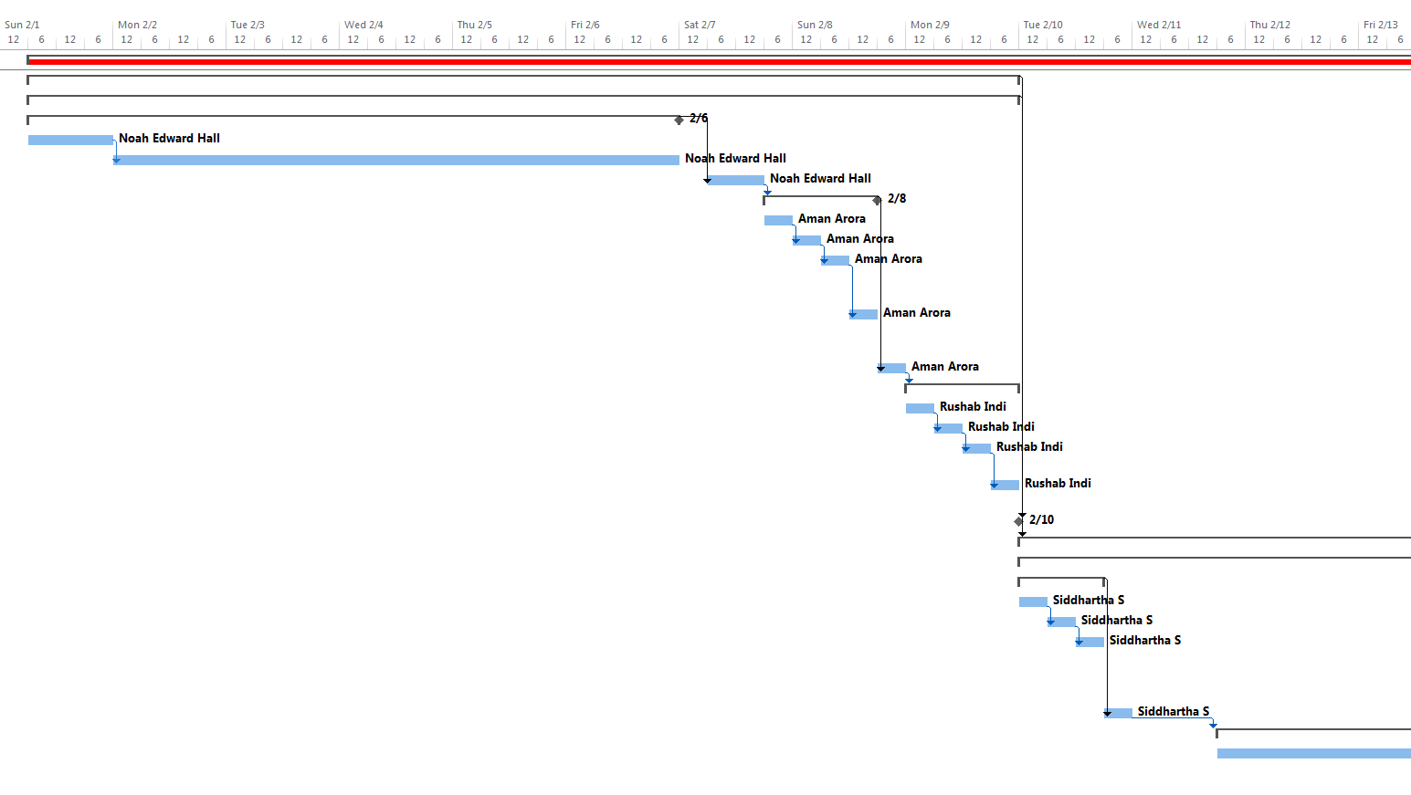

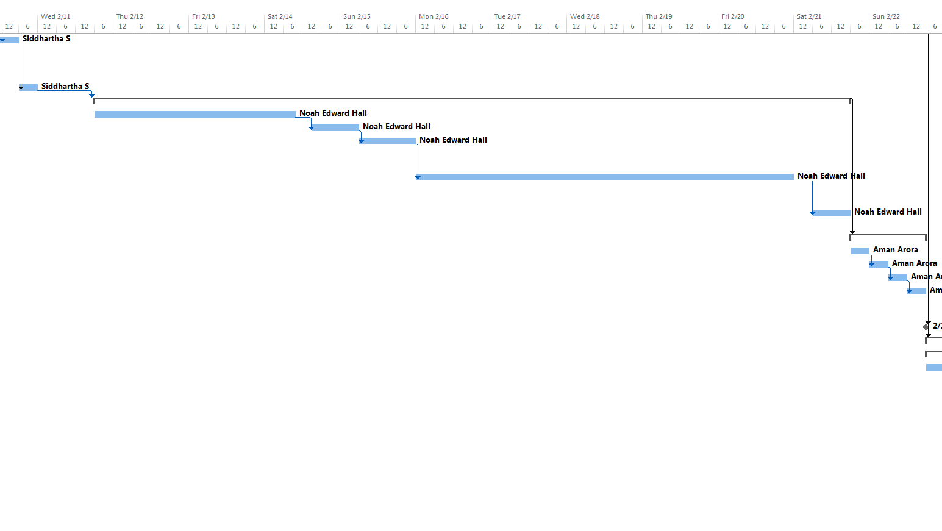

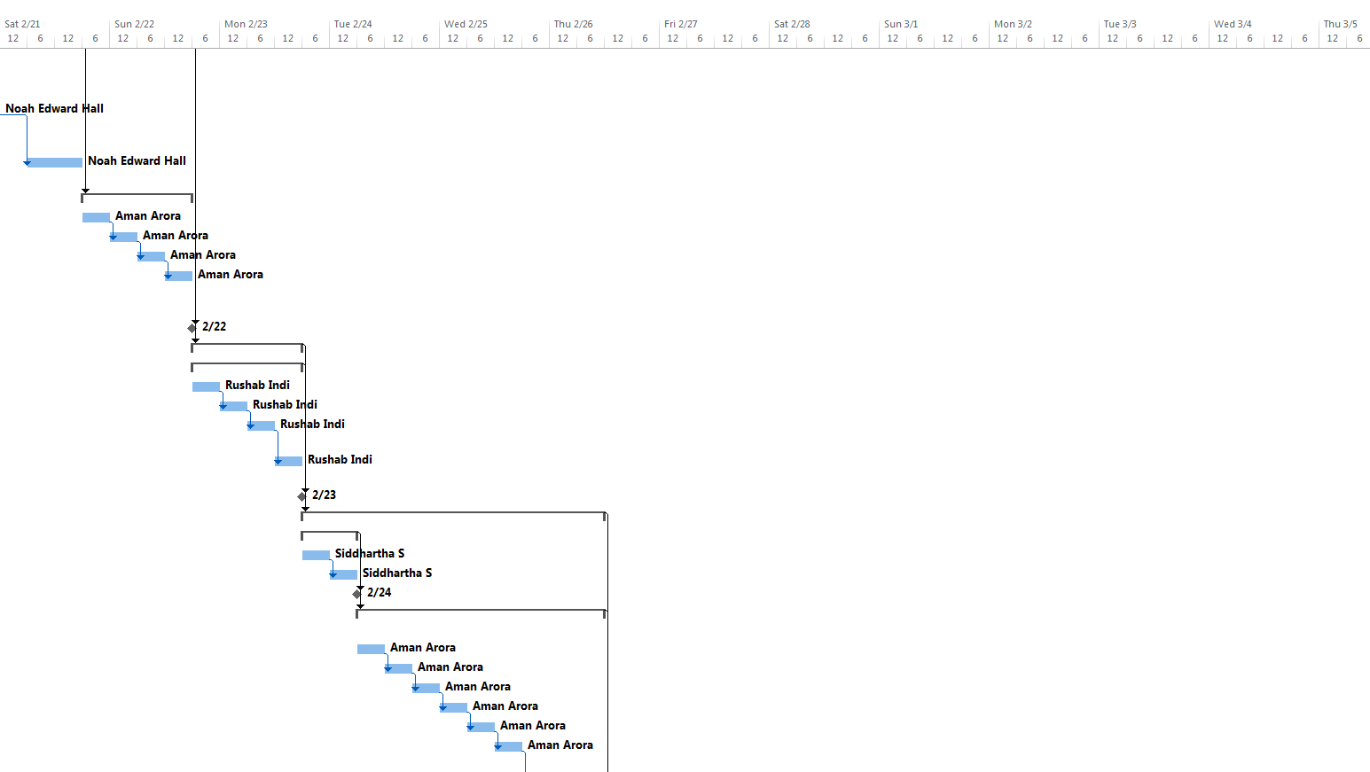

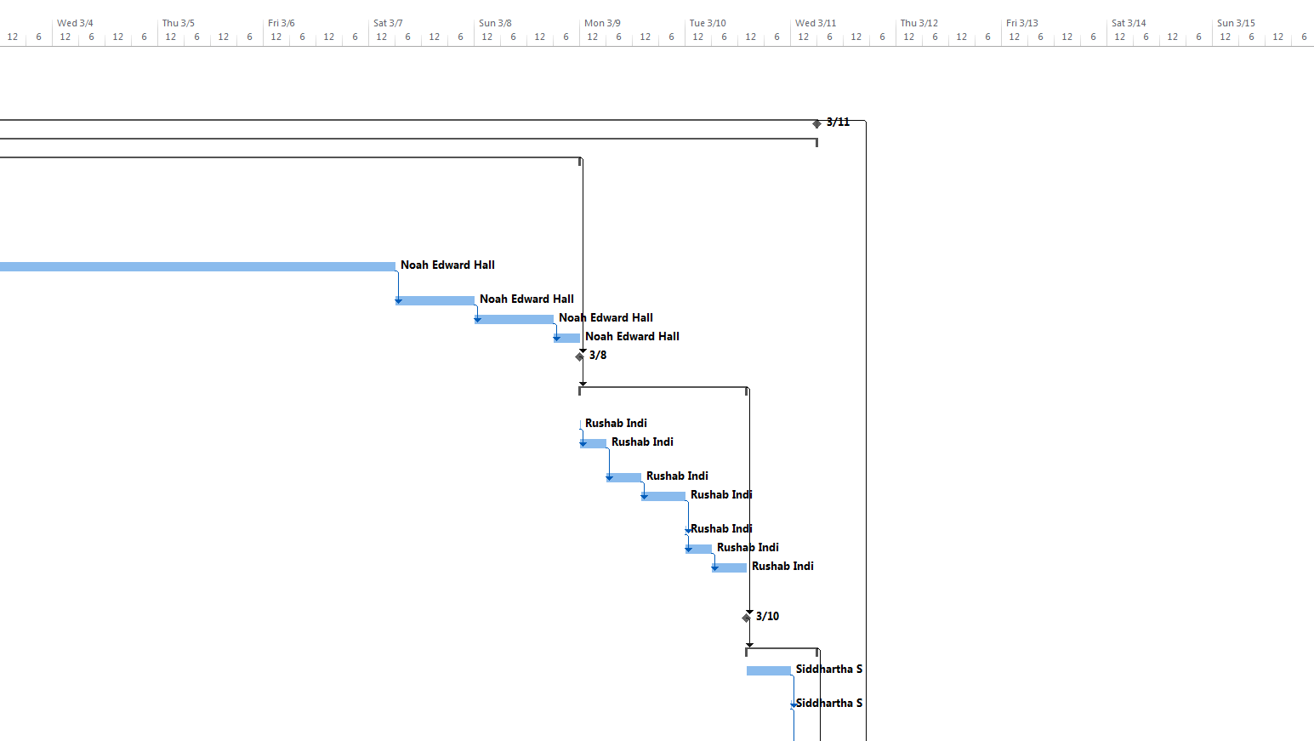

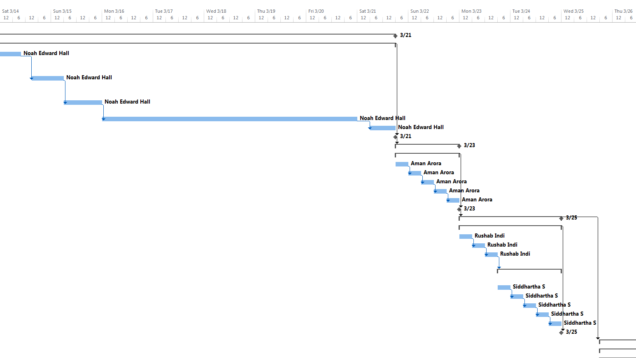

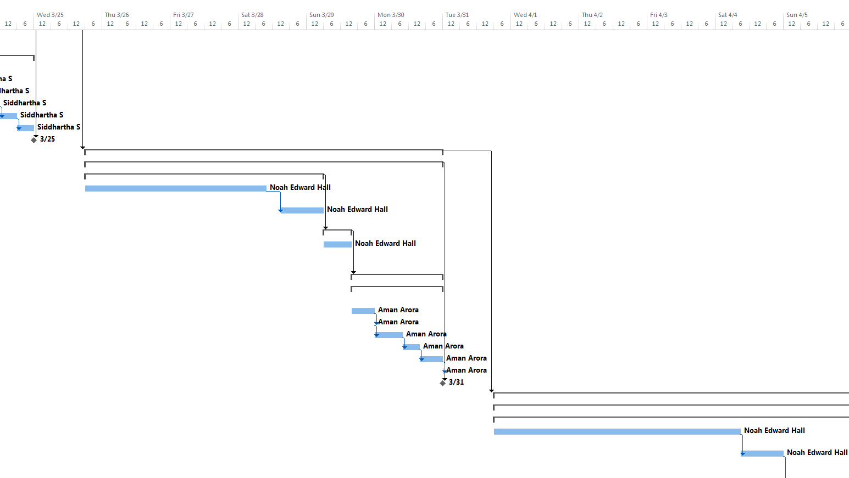

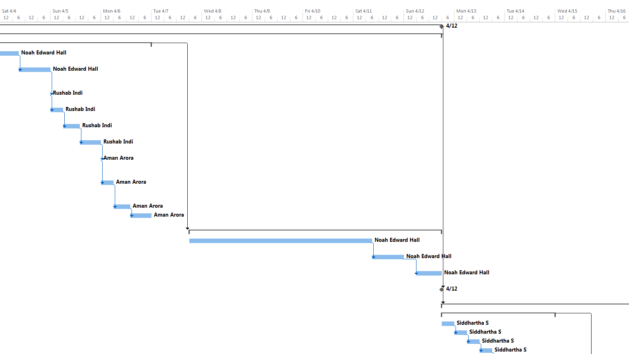

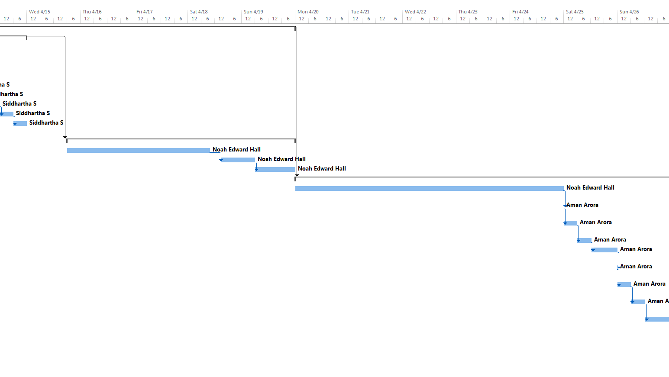

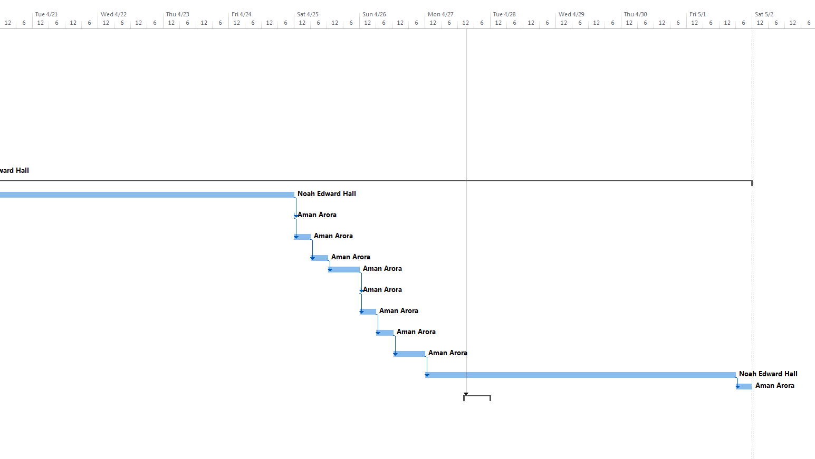

# Project Budget

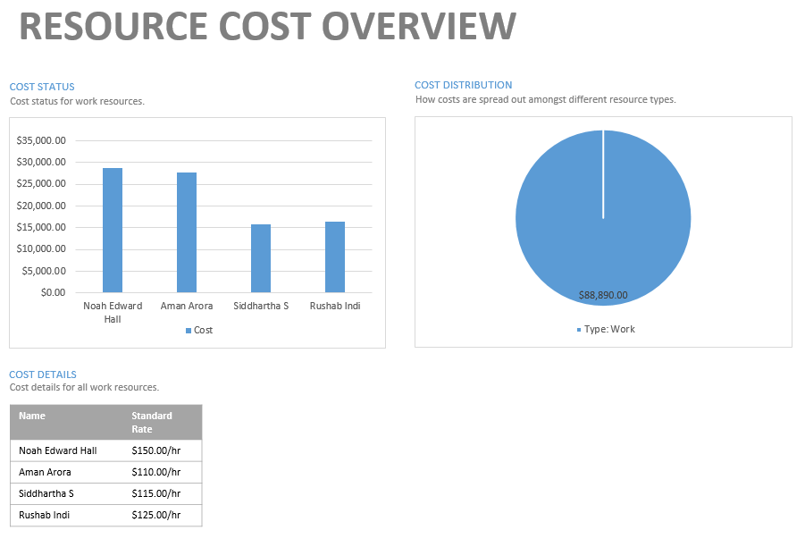

# Risk Management Plan

# Quality Management Plan

# Lesson Learned Reports

# APPENDIX

## MOV

|  |  |
| --- | --- |
| **QUARTER - YEAR** | **MOV** |
| Q3 2015 | Reduce energy required to build a professional entertainment network from searching 3 or more sites to one site |
| Q3 2015 | Create Projects, Post Ads, Find Collaborators in 3 Screens or Less |
| Q1 2016 | Penetration of Three Markets |
| Q3 2016 | Grow Market Share to 3% |

## Comparison of Alternatives

### TCO

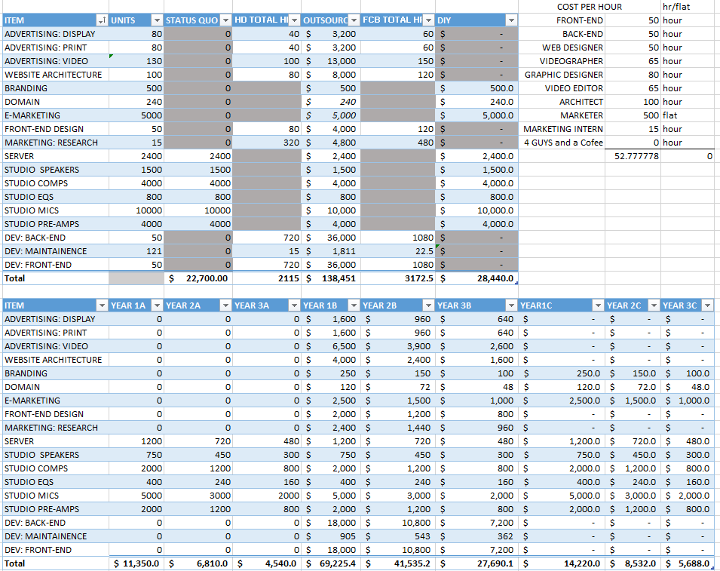

### TBO

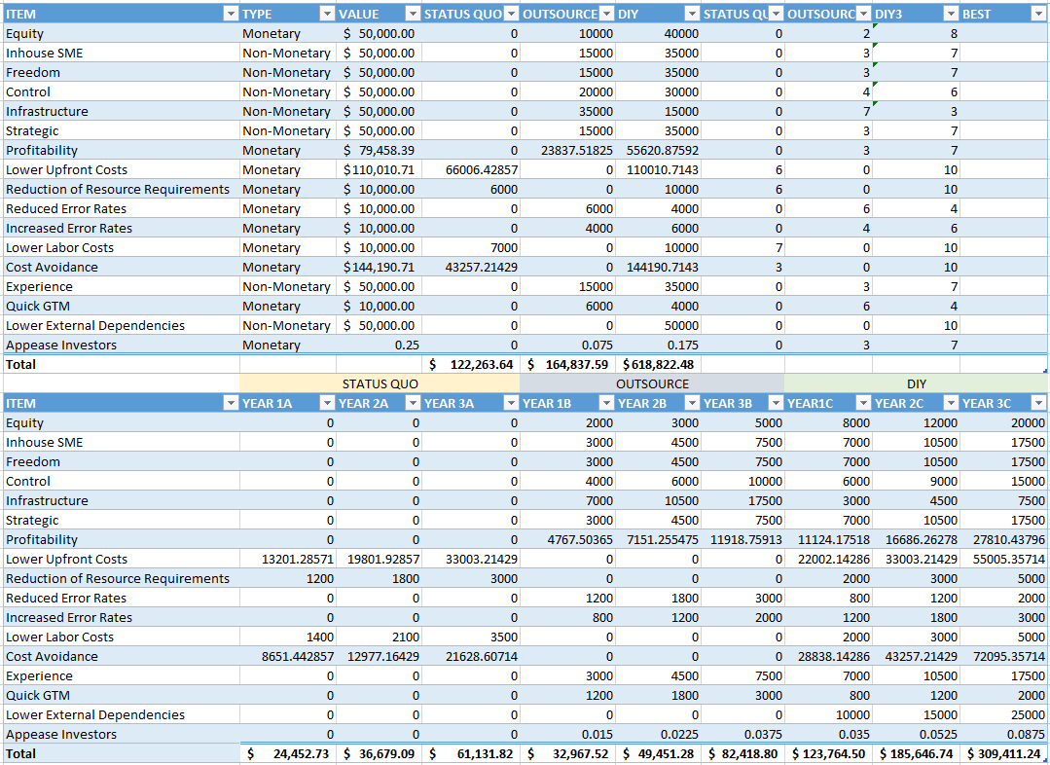

### Weighted Scoring Model

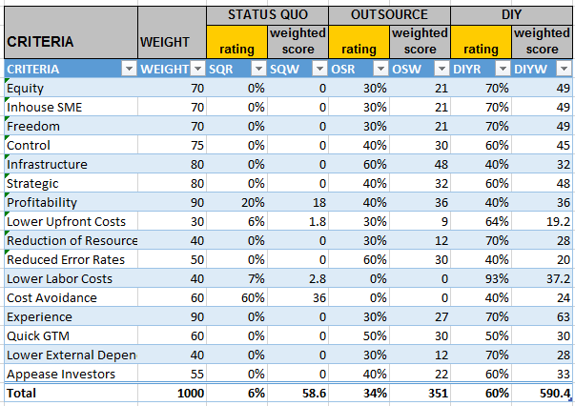

### 

### 

### 

### 

### 

### 

### 

### 

### 

### 

### 

### NPV / ROI

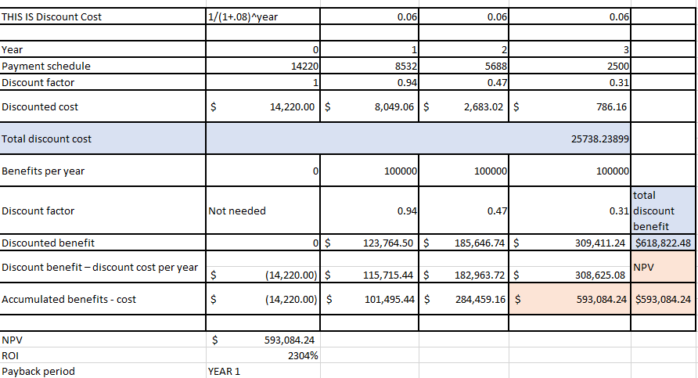

Risk Management